Project Design Phase-II

Data Flow Diagram & User Stories

|  |  |
| --- | --- |
| Date | 22 March 2025 |
| Team ID | PNT2025TMID06665 |
| Project Name | Prediction plant growth stages with environment and management data using Power BI |
| Maximum Marks | 4 Marks |

**Data Flow Diagrams:**

A Data Flow Diagram (DFD) is a traditional visual representation of the information flows within a system. A neat and clear DFD can graphically depict the right amount of the system requirement. It shows how data enters and leaves the system, what changes the information, and where data is stored.

**Example:** [**(Simplified)**](https://developer.ibm.com/patterns/visualize-unstructured-text/)

**Data Flow Diagram:**

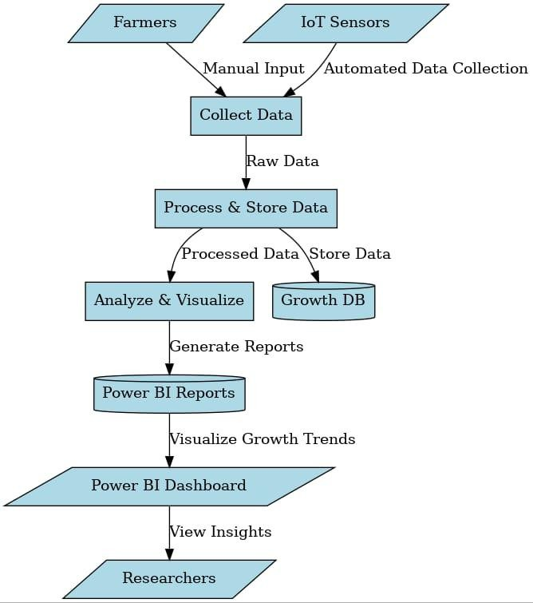

**User Stories**

Use the template below to list all the product's user stories.

|  |  |  |  |  |  |  |
| --- | --- | --- | --- | --- | --- | --- |
| **User Type** | **Functional Requirement (Epic)** | **User Story Number** | **User Story / Task** | **Acceptance criteria** | **Priority** | **Release** |
| Customer (Mobile user) | Registration | USN-1 | As a user, I can register for the application by entering my email, and password, and confirming my password. | I can access my account/dashboard | High | Sprint-1 |
|  |  | USN-2 | As a user, I will receive a confirmation email once I have registered for the application. | I can receive a confirmation email & click confirm | High | Sprint-1 |
|  |  | USN-3 | As a user, I can register for the application through Facebook | I can register & access the dashboard with Facebook Login | Low | Sprint-2 |
|  |  | USN-4 | As a user, I can register for the application through Gmail. | - | Medium | Sprint-1 |
|  | Login | USN-5 | As a user, I can log into the application by entering my email & password | - | High | Sprint-1 |
|  | Dashboard | - | - | - | - | - |
| Customer (Web user) | - | - | - | -- | - | - |
| Customer Care Executive | - | - | - | - | - | - |
| Administrator | - | - | - | - | -- | - |

|  |  |  |  |  |  |  |
| --- | --- | --- | --- | --- | --- | --- |
| **User Type** | **Functional Requirement (Epic)** | **User Story Number** | **User Story / Task** | **Acceptance criteria** | **Priority** | **Release** |
| Agronomist / Researcher | Data Ingestion | USN-1 | As a researcher, I can upload environmental and management data into Power BI. | I can see my uploaded data in Power BI for analysis. | High | Sprit-1 |
|  |  | USN-2 | As a researcher, I can integrate IoT sensor data for real-time monitoring of environmental conditions. | IoT data is visible in Power BI dashboards. | High | Sprit-2 |
| Farm Manager | Visualization & Analysis | USN-3 | As a farm manager, I can view plant growth stages predicted based on environmental factors. | I can see visualized predictions for each crop cycle. | High | Sprit-1 |